The Tribe Of Judah In The Bible
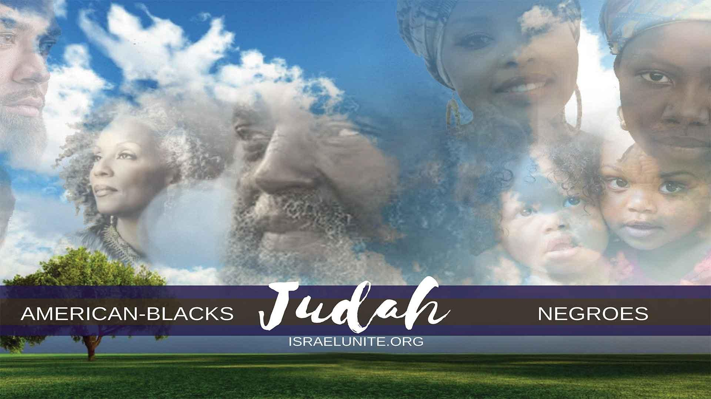
The tribe of Judah (American Blacks) along with Benjamin and Levi were sold into captivity by the Africans and the Arabs to the white-man. The white man then transported them in chains on slave ships to America to serve hard bondage as slaves.
Judah was the fourth born son of Jacob, his name means “Yahawah’s Praise”, Genesis 29:35. “And she conceived again, and bare a son: and she said: Now will I praise the Lord: therefore she called his name Judah; and left bearing.” They came to America in cargo slave ships between the late 1500’s – early 1800’s.
Psalms 78:2-4, “I will open my mouth in a parable; I will utter dark sayings of old: which we have heard and known, and our fathers have told us. We will not hide them from their children shewing to the generation to come the praises of the Lord…”
“I will open my mouth in a parable; I will utter dark sayings of old”, is prophetic of Christ!” In Mathew 13:10, “And the disciples came and said unto him, Why speakest thou unto them in parables?” Christ explains that unto the masses of Israel the proper understanding of the scriptures was not given, but rather for them: the disciples, whose job it was to teach Israel. Guiding them back to the Heavenly Father through Christ. Matthew 10:5-7
“We will not hide them from their children shewing to the generation to come the praises of the Lord.” It is the disciple’s job to teach the true understanding of the Bible in the name of Christ and not hide the mysteries of the Lord but instead make it clear to all.
Genesis 49:1, “And Jacob called unto his sons, and said, gather yourselves together, that I may tell you that which shall befall you in THE LAST DAYS.” Read Heb. 1:2.
Genesis 49:8. “Judah, thou art he whom thy brethren shall praise: thy hand shall be in the neck of thine enemies; thy fathers’ children shall bow down before thee.”
“Judah, thou art he whom thy brethren shall praise”, all the tribes of Israel shall praise the tribe of Judah for bringing them the truth, and for the risks they took to help Israel under oppression.
Thy hand shall be in the neck of thine enemies”, for many decades the American blacks have risked their lives fighting with America’s political system for justice, equality, housing, desegregation, jobs and education. They’ve marched for miles, held vigil’s, boycotted, fought against law enforcement resulting in thousands of them being burned, lynched, hosed, attacked by dogs, clubbed, whipped, raped sodomized, firebombed. More importantly Judah has fought to bring out the truth about the Israelites. By Judah’s hand being in the neck of his enemies (America) he has choked the American political system for all kinds of benefits. As the American blacks begin to wake up and return to the Lord (as Judah), they are choking the lies of Americas’ educational and religious institutions; by teaching the truth of the Bible, proving Christ, is black and only died for the nation of Israel, and that the so called Negro and Indian scattered throughout the Americas are Israelites.
“The neck of thine enemies”, is also giving you the geographical location of the tribe of Judah – North America.
Zechariah 2:6-7, “Ho, ho, come forth and flee from the land of the NORTH (North America).. ..Deliver thyself. O Zion that dwellest with the daughter of Babylon (America)…”
Jeremiah 16:14-15
Psalms 137:7-8, “Remember O Lord the children of EDOM… O daughter of Babylon…”
These prophetic scriptures tell us the people of EDOM (so called white people) are the daughter of Babylon (in North America), and Judah, would dwell there in captivity.
Genesis 49:8B, “….thy father’s children shall bow down before thee.” In the end, all the tribes of Israel shall praise and bow down before Judah, because they will acknowledge that Judah is the head tribe and have fought to teach the truth to Israel and this is mainly due to Christ..
Zechariah 12:7, “The Lord also shall save the tents of Judah first that the glory of the house of David and the glory of the inhabitants of Jerusalem do not magnify themselves against Judah.”
Although the American blacks, have fought for many causes and brought about much change to the benefit of all the other tribes of Israel (better schooling, better jobs, better housing and many other benefits), all the tribes of Israel mock and look down on the American black. The West Indian blacks, Haitians, (the House of David), Puerto Ricans, and the Mexicans (inhabitants of Jerusalem) belittle and insult the American blacks, calling them lazy, thieves, no good bums, stupid etc. Therefore, the Lord promised that he will save Judah first, by giving him the understanding of the scriptures to teach and gather the other tribes of Israel under Christ; thereby all Israel will acknowledge Judah as the head tribe.
Genesis 49:9, “Judah is a lion’s whelp: from the prey my son, thou art gone up: he stooped down, he couched as a lion, and as an old lion; who shall rouse him up?
“Judah is a lions whelp”, meaning the tribe of Judah is like a young lion powerful and fearless: from the prey, my son, thou art gone up”, Just like a young lion cub is hunting his “prey” and then gives up the hunt and becomes distracted. The “prey” is the enemies; the white man and all the other nations. But Judah, has left going after the prey, leaving the truth of the Bible, and became distracted/tricked by the philosophies of his enemies; religion. Christianity – Muslim etc., crime, selling drugs, killing each other, integration – thereby he has ceased from the hunt of his enemies.
“He stooped down”, meaning just as a lion stoops down with intentions to attack and devour his prey. Likewise in the 40’s, 50’s, and 60’s the American blacks stooped down – formed various organizations to consider devouring the so called white man, for the injustice and oppression they have suffered.
“He couched as a lion” meaning just as a lion couches about to attack, to devour his prey, so did the American blacks. In the late 50’s and 60’s they formed militant groups; no longer passive marches of protests but now carrying weapons in direct defiance of local law officials, it was time for kill or be killed, eye for an eye, tooth for a tooth. It was time for revolution, and during this era it appeared as if the American blacks would devour their enemies.
“And as an old lion”, Judah, this young powerful lion was distracted from his purpose by infiltration and drugs in the black community, as an old lion gets tired and gives up the hunt, so did the various black militant groups. Infiltration and drug addiction caused Judah to lay down arms, and become complacent in society. This was a diabolical plot by the Illuminati, the CIA and the FBI.
“Who shall rouse him up”, only the Most High, can rouse the spirit of the American blacks to the truth, and take his position as the tribe of Judah of the nation of Israel. In Zechariah 12:7, the Most High promised to rouse Judah up by saving his tents first by the proper understanding of the Bible!!!
Revelation 11:11, “And after three days and an half the Spirit of life from God entered into them, and they stood upon their feet; and great fear fell upon them which saw them.” Also read Ezekiel 37:1-10
Three days and an half is symbolic for 350 years when the bulk of the slaves were brought into the hands of America in 1620 (Read Daniel 7:25). 350 years after 1620 brings us to around 1970; it was about 1970 when the truth really began to be pushed and taught concerning who the American blacks were – the real Jews. “The Spirit of life from God entered into them/’ meaning the proper understanding of the Bible began to be taught in the name of CHRIST
John 6:63 “…the words that I speak unto you: they are spirit, and they are life. ” Therefore, the true knowledge would come thru faith in Jesus Christ, that is the Spirit of life from God

Genesis 49:
v10- The Sceptre Shall Not Depart from Judah, nor a Lawgiver from between his feet, until Shiloh come; and unto him shall the gathering of the people be.
“The sceptre shall not depart from Judah…”, means the rulership shall not depart from the tribe of Judah; the King of Kings will come from Judah.
“Nor a Lawgiver from between his feet…”, means the High Priest shall come from the SEED of Judah. What is between a man’s feet; His penis. This proves Christ was born through sex and NOT “Immaculate Conception”.
“Until Shiloh come”, Shiloh means peaceable which is Jesus Christ.
Read Hebrews chapter 7, it explains how Jesus Christ is after the order of Melchesidec. King of peace as well as our High priest. “Until Shiloh come” properly translated says “when Shiloh comes”. Prior to the coming of Christ it was the tribe of Levi that held the sceptre (rulership) ever since the days of the Maccabees.
During the ministry of Christ, the high priest was Caiaphas – a Levite, read John 18:13. The historian Flavius Josephus records how Levi governed Israel under Roman rule. However when Christ came the Sceptre was handed to the tribe of Judah.
“…and unto him shall the gathering of the people be” Means unto Christ shall the gathering of Israel be.
Zechariah 12:7, “The Lord shall save the tents of Judah first…”, therefore Judah would be the first teachers of the Lord leading Israel unto Christ.
This also proves the Twelve Tribes of Israel cannot be gathered except through Jesus Christ.

Isaiah 53:
V10- Yet It Pleased The Lord To Bruise Him; he hath put him to grief; when thou shalt make his soul an offering for sin, he shall see his seed, he shall prolong his days, and pleasure of the Lord shall prosper in his hand.
V11- He shall see the travail of his and shall be satisfied: by his knowledge shall my righteous servant justify many; for he shall bear their iniquities.
Acts 10:
v36– “The word which God sent unto the children of Israel, preaching peace by Jesus Christ…”
The leaders of the Jews said this concerning Christ:

John 11:
v48- If we let him thus alone, all men (Israelites) will believe on him: and the Romans shall come and take away both our place and nation.”
This verse was prophetic of Genesis 49:10. When Christ came and died for the sins of Israel then was resurrected. In the year 70 A.D., the Romans laid siege against Israel. Taking away afterwards both the place of Judah, as the religious leaders and their nation, leading them into captivity.
“And unto him shall the gathering of the people be“, the him is Jesus Christ, of the tribe of Judah.

Hebrews 7:
v14- For it is evident that our Lord (Christ) sprang out of Juda; of which tribe Moses spake nothing concerning priesthood

Genesis 49:
v11 Binding his foal unto the vine, and his ass’s colt unto the choice vine; he washed his garments in wine, and his clothes in the blood of grapes:
The “vine” is referring to the grape vine.

Matthew 21:
v2- Saying unto them, go into the village over against you, and straightway ye shall find an ass tied, and a colt with her: loose them, and bring them unto me.

Zechariah 9:
v9- Rejoice greatly O daughter of Zion: shout, O daughter of Jerusalem: behold, thy King cometh unto thee: he is just, and having salvation; lowly and riding upon an ass, and upon a colt the foal of an ass.
“he washed his garments in wine, and his clothes in the blood of grapes”, is referring to Christ destroying the Edomite nations.

Isaiah 63:
V1- Who is this that cometh from Edom, with dyed garments from Bozrah? This that is glorious in his apparel, travelling in the greatness of his strength? I that speak in righteousness, mighty to save.
V2- Wherefore art thou red in thine apparel, and thy garments like him that treadeth in the winefat?
V3- I have trodden the winepress alone: and of the people there was none with me: for I will tread them in mine anger, and trample them in my fury; and their blood shall be sprinkled upon my garments, and I will stain all my raiment.
Genesis 49:
v12- His eyes shall be red with wine, and his teeth white with milk.
“His eyes shall be red with wine”, means that the Messiah (Christ) would drink so much wine that the iris of his eyes would appear red (meaning the whites of his eyes were red).
Mathews 11:
v19- “The son of man came eating (meat) and drinking (wine) and they say behold a man gluttonous, and a wine bibber.

Daniel 10:
V5- Then I lifted up mine eyes, and looked, and behold a certain man clothed in linen, whose loins were girded with fine gold of Uphaz:
V6- His body also was like the beryl (wore a green garment) and his face as the appearance of lightning, and his eyes as lamps of fire (red with wine), and his arms and his feet like in colour to polished brass, and the voice of his words like the voice of a multitude.”

Revelation 1:
V13- And in the midst of the seven candlesticks one like unto the son of man, clothed with a garment down to the foot, and girt about the paps with a golden girdle.
V14- His head and his hairs were white like woof as white as snow and his eyes were as a flame of fire (red with wine)
V15- And his feet like unto fine brass as if they burned in a furnace: and his voice as the sound of many waters.
“and his teeth white with milk.” This is another trait Christ and the tribe of Judah, would have; pearly white teeth. During the days of slavery and segregation, the so-called white man made mockery of the American Blacks dark skin against their bright white teeth, (example, the sambo and mammy pictures)

Deuteronomy 33:
v7- And This Is the Blessing Of Judah: and he said, Hear Lord the voice of Judah: and bring him unto his people: let his hands be sufficient for him; and be thou an help to him from his enemies.
“Hear Lord the voice of Judah“, although the Lord has aided his people in their moments of need, this is truly prophesying the time to come when the American blacks, will repent of their disobedience and return unto the Lord, as the tribe of Judah of the nation of Israel and teach who the 12 tribes of Israel are and lead them to Christ.
Let’s prove that:

II Chronicles 6:
v36- If they sin against thee, (for there is no man which sinneth not) and thou be angry with them, and deliver them over before their enemies, and they carry them away captives unto a land far off or near:
v37- yet if they bethink themselves (remember they are the Israelite’s) in the land whither they are carried captive (America), and turn and pray unto thee in the land of their captivity, saying we have sinned, we have done amiss, and have dealt wickedly;
v38- If they return to thee with all their heart and with all their soul (keep commandments) in the land of their captivity. whither they have carried them captives, and pray toward their land (Israel) which thou gavest unto their fathers, and toward the city which thou hast chosen (Jerusalem), and toward the house which I have built for thy name:
v39- Then hear thou from the heavens, even from thy dwelling place, their prayer and their supplications, and maintain their cause (deliver them from evil and destroy their enemies) and forgive thy people which have sinned against thee.
“And bring him unto his people“, meaning bring Judah, with the perfect knowledge of the Bible, in Christ, unto his people the tribes of Israel. Therefore Judah, will be the main force in Christ, to teach the children of Israel.
“Let his hands be sufficient for him”, meaning Judah, would have to fight and work hard for everything he acquires. The American blacks, have literally built up America, aiding in many inventions claimed by the so-called white man.
“Be thou an help to him against his enemies“, if it were not for the help of the Heavenly Father, Judah (the American blacks) would have been totally destroyed by now: from the turmoil of the middle passage, the hard bondage in America, the Civil War, the lynching and fire bombings by the KKK, the infamous Tuskegee Experiment (when Judah was infected with Syphilis) bad food, medicine, and mass drug trafficking throughout their communities etc.”
All nations that suffered under the hands of the so called white reaped reparations. Even 11 of the tribes of Israel, have a type of homeland allocated to them, except for Judah.
The American blacks have yet to receive the 40 acres and 2 mules America promised them.

Jeremiah 22:
v13- Woe unto him that buildeth his house (America) by unrighteousness and his chambers by wrong (slavery); that useth his neighbors service without wages, and giveth him not for his work.
This is what the sin that an Israelite named Shallum, was guilty of and the Lord passed severe judgement on him, so how much more will America be judged.

Jeremiah 11:
v13- For according to the number of thy cities were thy Gods, O Judah; and according to the number of the streets of Jerusalem have ye set up altars to that shameful thing, even altars to burn incense unto Baal.
This explains that wherever Judah (the American blacks) are, they have false churches set up on every other street worshiping that shameful white image of Jesus Christ (which is really Cesare Borgia) screaming hallelujah.
Bibliography
“Malcolm X- The End of White World Supremacy”
By IMAM Benjamin Karim
Page 72 – “The honorable Elijah Muhammed teaches us that these same so-called American Negroes are God’s long lost people, who are symbolically described in the Bible as the lost sheep of the Lost tribes of Israel.”

